**S3(Simple storage service)**

1. **Create s3 bucket and upload some objects to s3.**

**To create s3 bucket**

**s3 ---> Buckets ---> create bucket --->Name ---> object ownership(ACL enable) --->Block all public access(disable) --->Bucket version(disable)**

**--->Defoult encryption(disable) ---> create bucket**

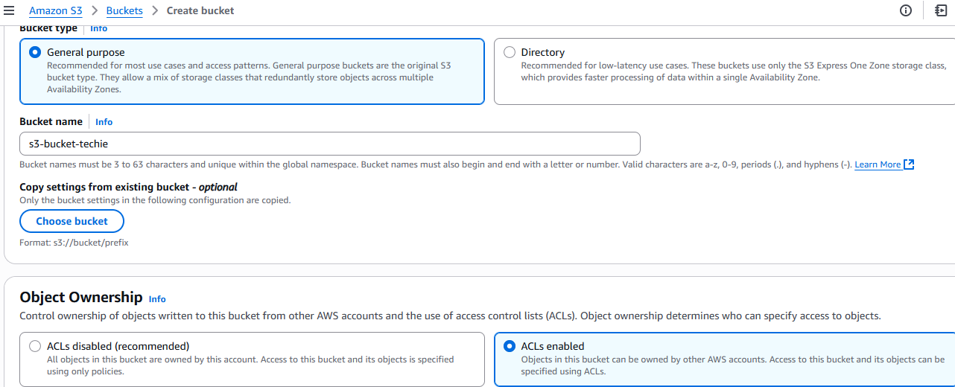

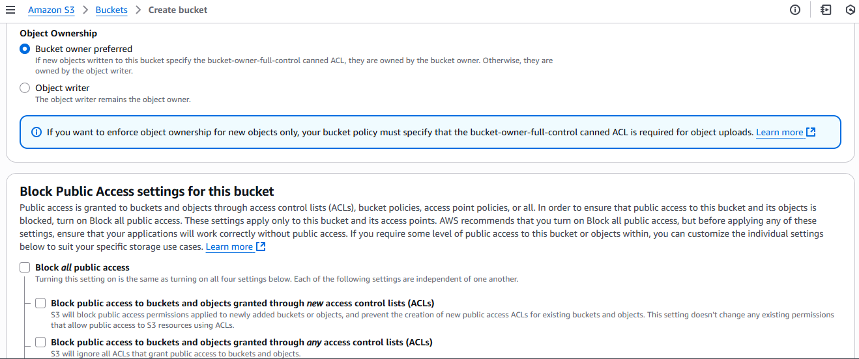

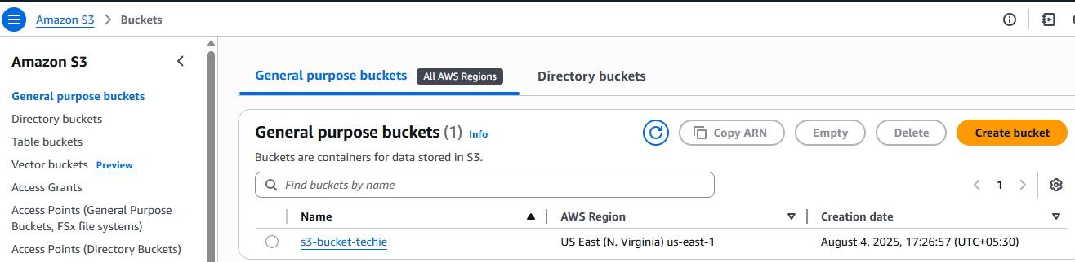

**To upload some objects to s3**

**S3 ---> Buckets ---> select the bucket ---> objects ---> upload ---> Add files ---> upload**

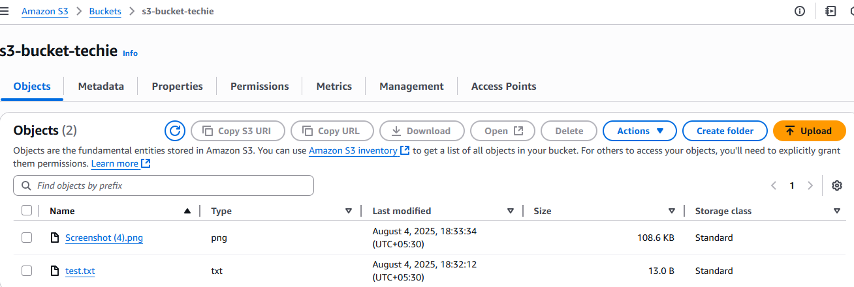

**2)Deploy static website in s3 bucket.**

**Upload website files to s3**

**S3 ---> Buckets ---> select the bucket ---> objects ---> upload ---> Add website files ---> upload**

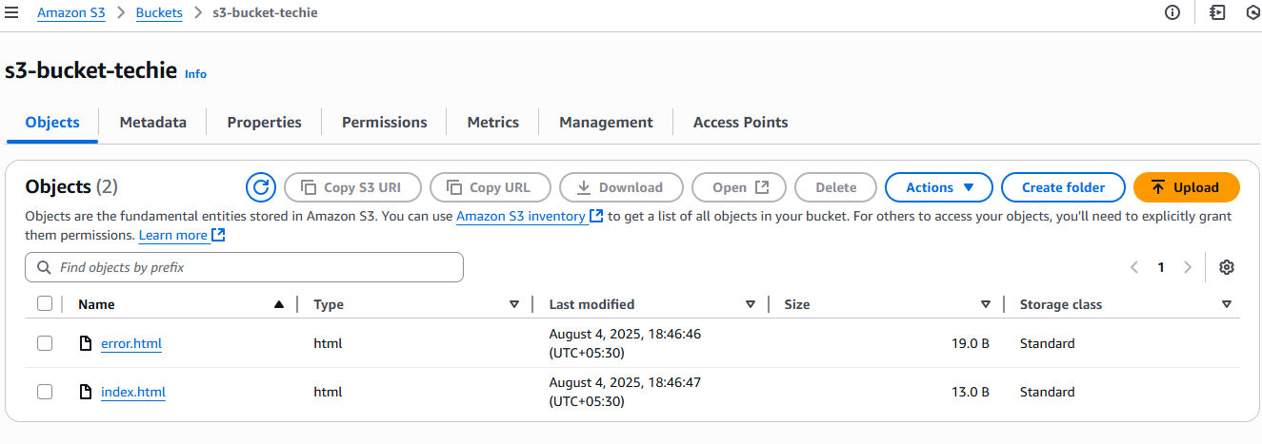

**Select created files ---> Actions ---> make public using ACL ---> make public**

**To enable static website hosting**

**S3 ---> Buckets ---> select the bucket ---> properties ---> Static website hosting(enable) ---> Set index and error documents ---> save changes**

**After enable static website you will see url**

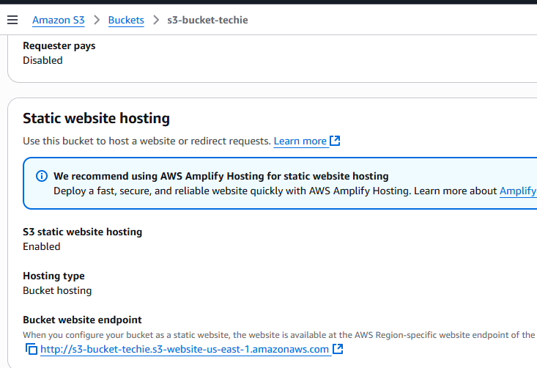

To click the url

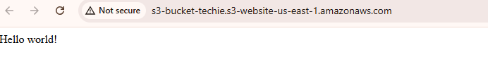

1. **Enable cross region replication on s3 buckets.**

**Create two buckets in different regions.**

Source bucket : **naveen124s3**

Destination bucket : **naveen241s3**

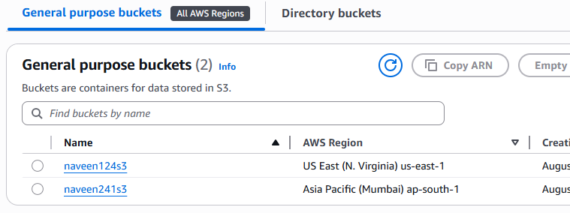

**Give permissions to:**

- Enable versioning

-create IAM roles

-configure replica rules

**S3 buckets replication**

**S3 ---> Buckets ----> select your bucket ---> Management**

**---> click create replication rule**

Rule settings:

Name: replication-to-west

Status: Enabled

Scope: Leave as All objects (or filter by prefix/tag)

Destination:

Bucket: Choose your destination bucket from dropdown (in another region)

Permissions:

Select Create new IAM role (recommended)

AWS will automatically create a role with required permissions

Click Save

Step3: now upload a file in source s3 then open and check Replication status pending ,completed or fail and check in dest S3 is file showing or not**.**

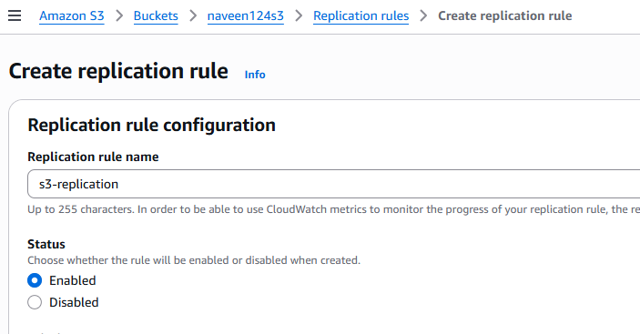

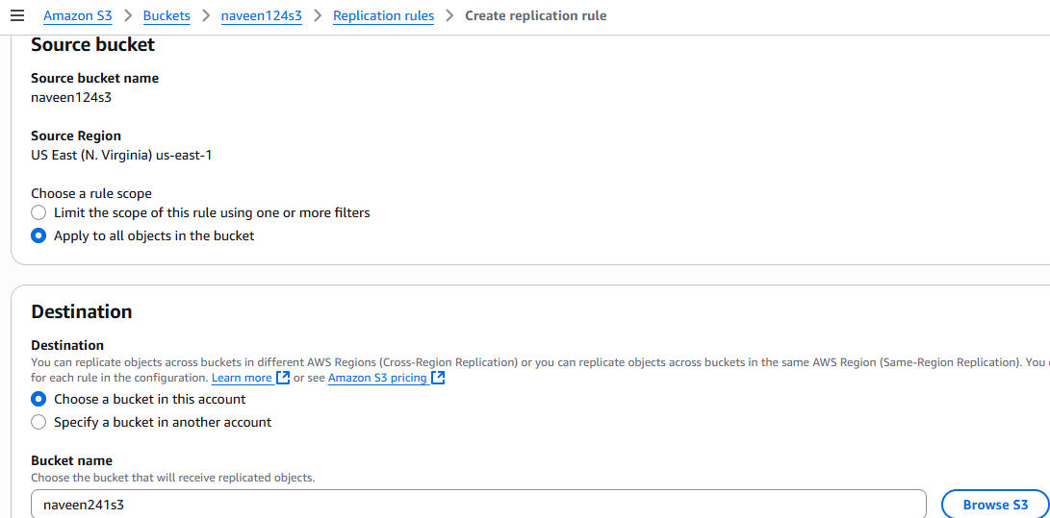

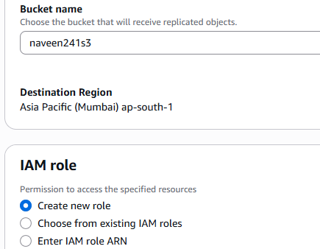

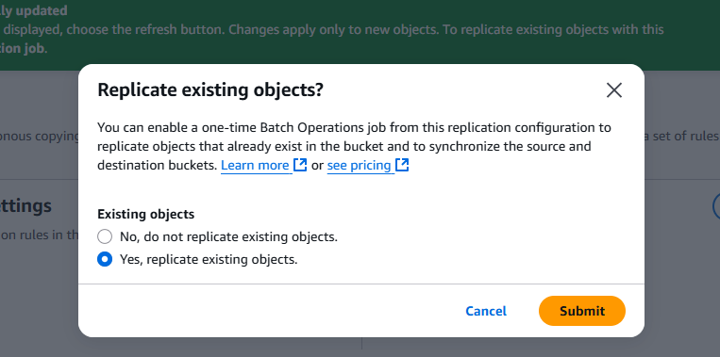

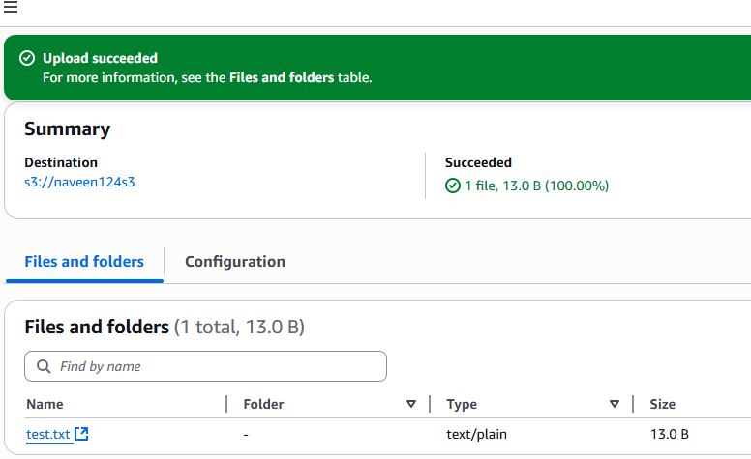

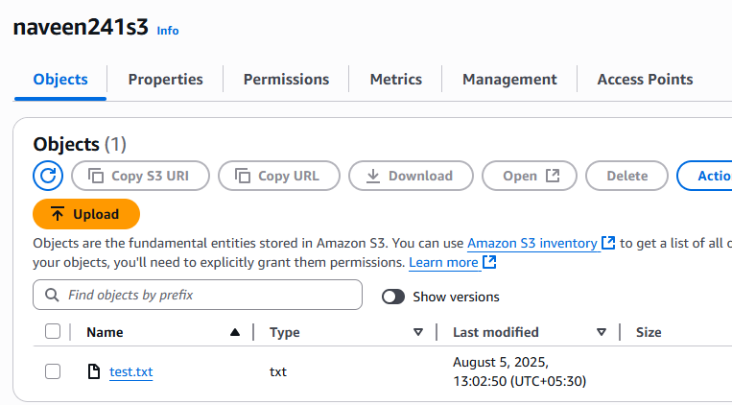

**4)Configure bucket policy,only Admin user can see the objects of s3 bucket.**

**Create a IAM user with name Admin**

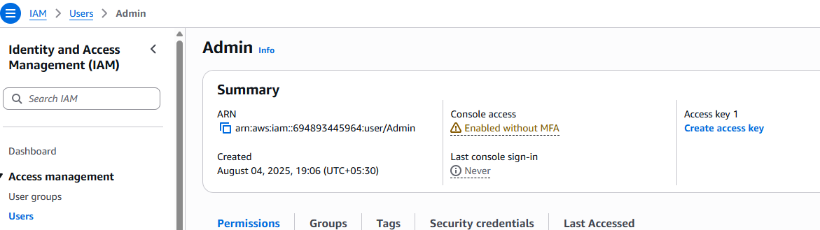

**Configure bucket policy to Admin user**

**S3 ---> Buckets ---> select created bucket ---> permission ---> edit**

**Bucket policy ---> click save changes**

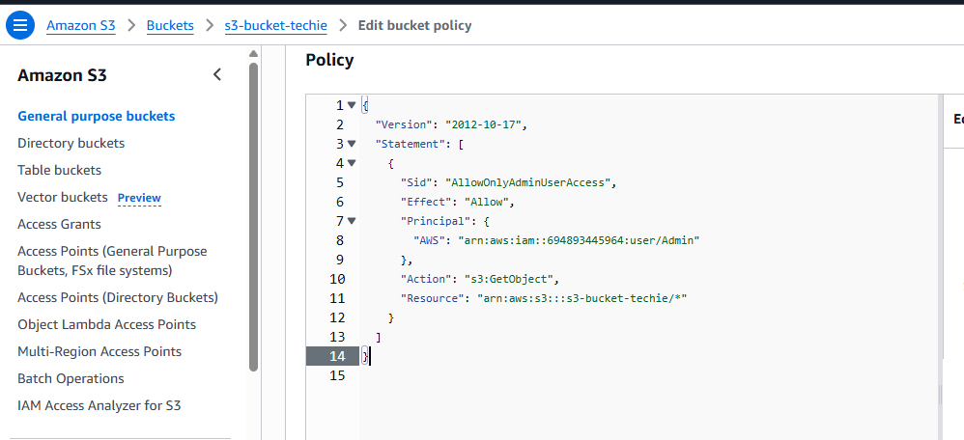

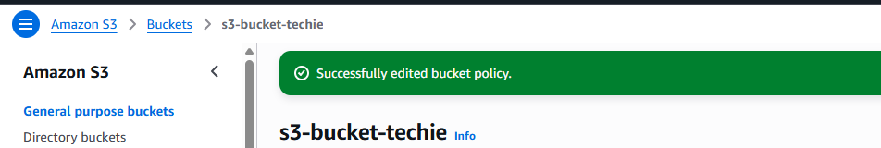

1. **Setup lifecycle policies to automatically transition or delete objects based on specific criteria.**

**Amazon s3 ---> Buckets ---> select created bucket ---> Management**

**---> click Create lifecycle rule**

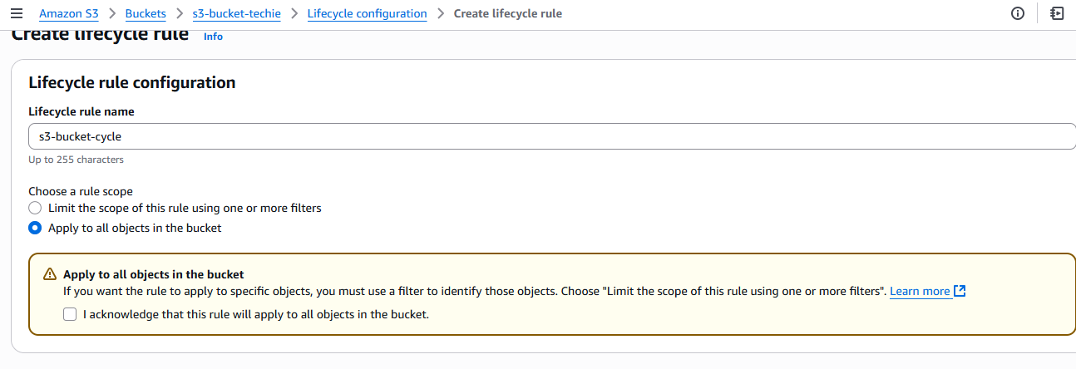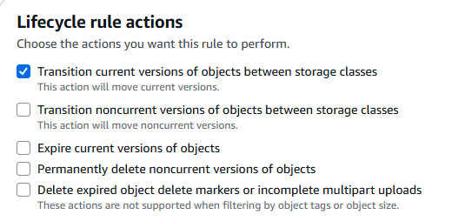

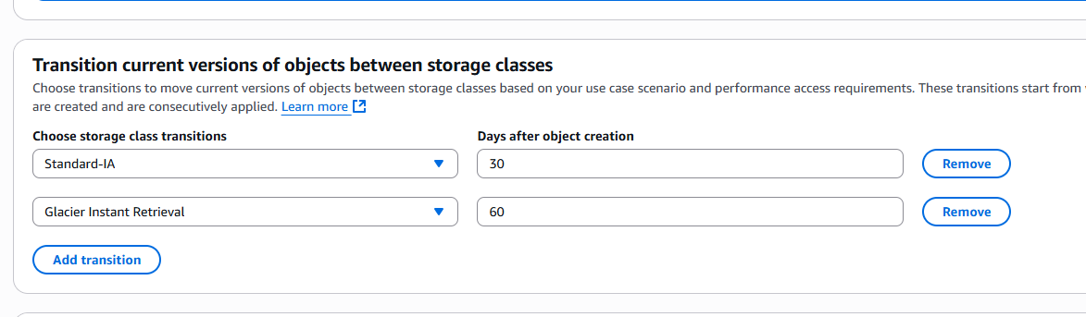

Then click **create rule** then **Lifecycle** is created.

1. **Push some objects in s3 using AWS CLI.**

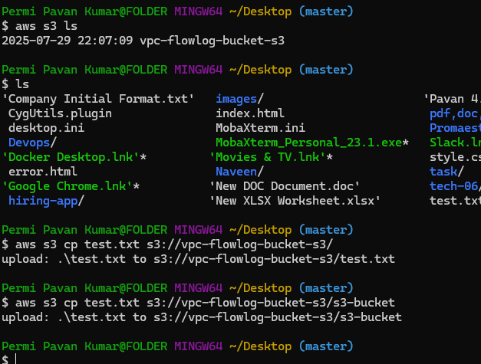

1. **Write a bash script to create s3 bucket.**

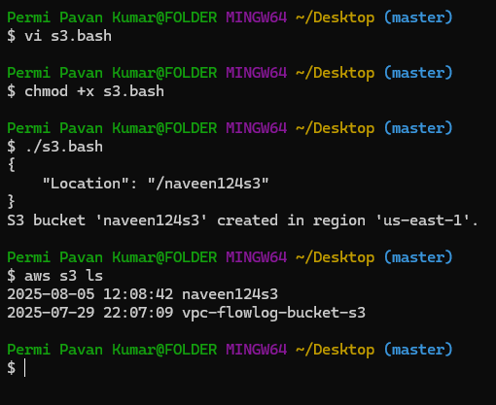

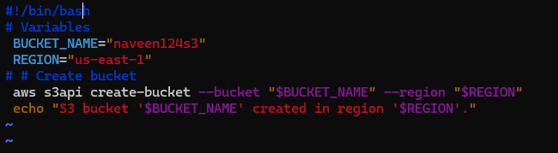

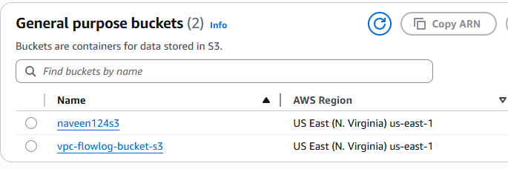

1. **Upload one 1 gb of file to s3 using cli.**

